Name : Anupam Kunwar
Reg : 19BCE1369

Packages

Q1.

MATRIX.java

package Anupam;
import java.util.Scanner;
public class MATRIX{
public int[][] arr = new int[3][3];
int i,j;
public MATRIX(){
for(i=0;i<3;i++){
for(j=0;j<3;j++){
arr[i][j] = 0;
}
}
}
public void readArr(){
Scanner in = new Scanner(System.in);
for(i=0;i<3;i++){
for(j=0;j<3;j++){
arr[i][j] = in.nextInt();
}
}
}
public void printArr(){
for(i=0;i<3;i++){
for(j=0;j<3;j++){
System.out.print(arr[i][j]+" ");
}
System.out.println();
}
}
public int[][] addArray(int[][] arr2){
int[][] sum = new int[3][3];
for(i=0;i<3;i++){
for(j=0;j<3;j++){
sum[i][j] = arr[i][j]+arr2[i][j];
}
}
return sum;
}
public int[][] subArray(int[][] arr2){
int[][] diff = new int[3][3];
for(i=0;i<3;i++){
for(j=0;j<3;j++){
diff[i][j] = arr[i][j]-arr2[i][j];
}
}
return diff;
}
}

testMatrix.java

import Anupam.MATRIX;
public class testMatrix{
public static void main(String[] args) {
MATRIX obj1 = new MATRIX();
MATRIX obj2 = new MATRIX();
MATRIX sum = new MATRIX();
MATRIX diff = new MATRIX();
System.out.println("\nEnter matrix1 elements : ");
obj1.readArr();
System.out.println("\nMatrix 1 elements are : ");
obj1.printArr();
System.out.println("\nEnter matrix2 elements : ");
obj2.readArr();
System.out.println("\nMAtrix 2 elements are : ");
obj2.printArr();
System.out.println("\nThe sum is : ");
sum.arr = obj1.addArray(obj2.arr);
sum.printArr();
System.out.println("\nThe difference is : ");
diff.arr = obj1.subArray(obj2.arr);
diff.printArr();
}
}

Output :
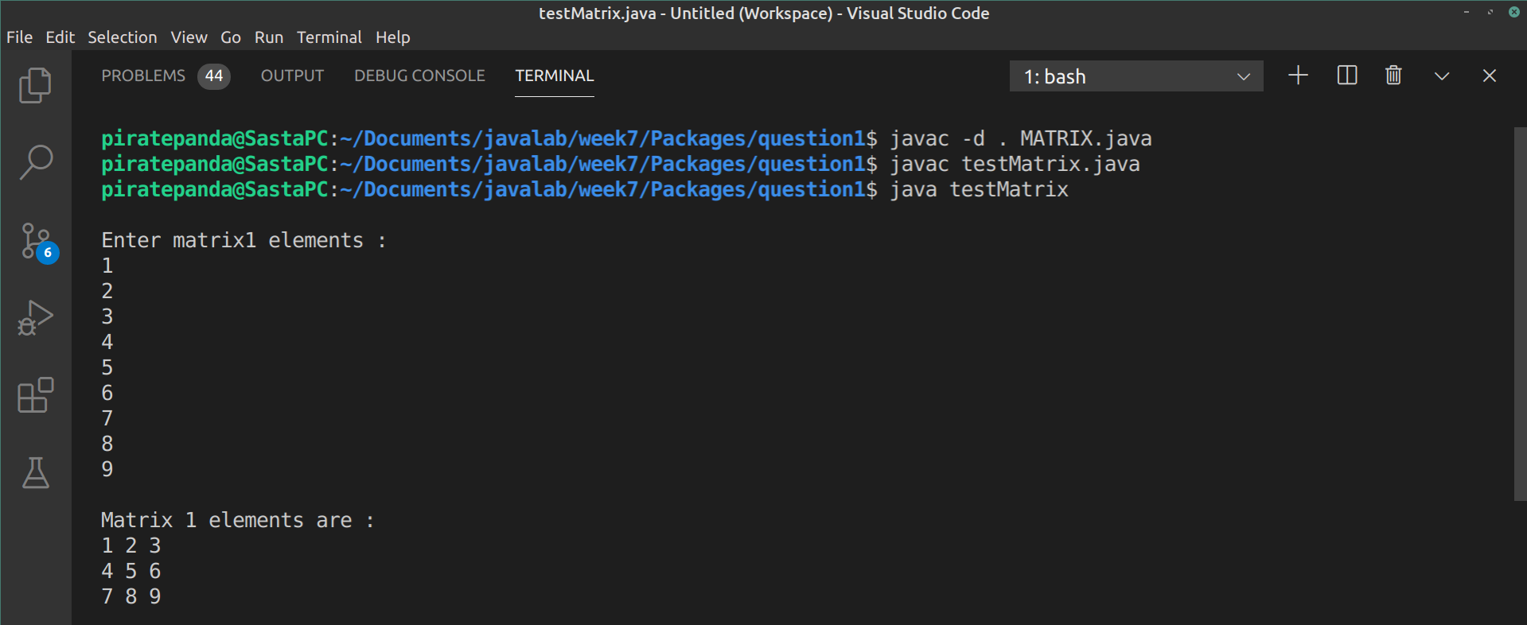
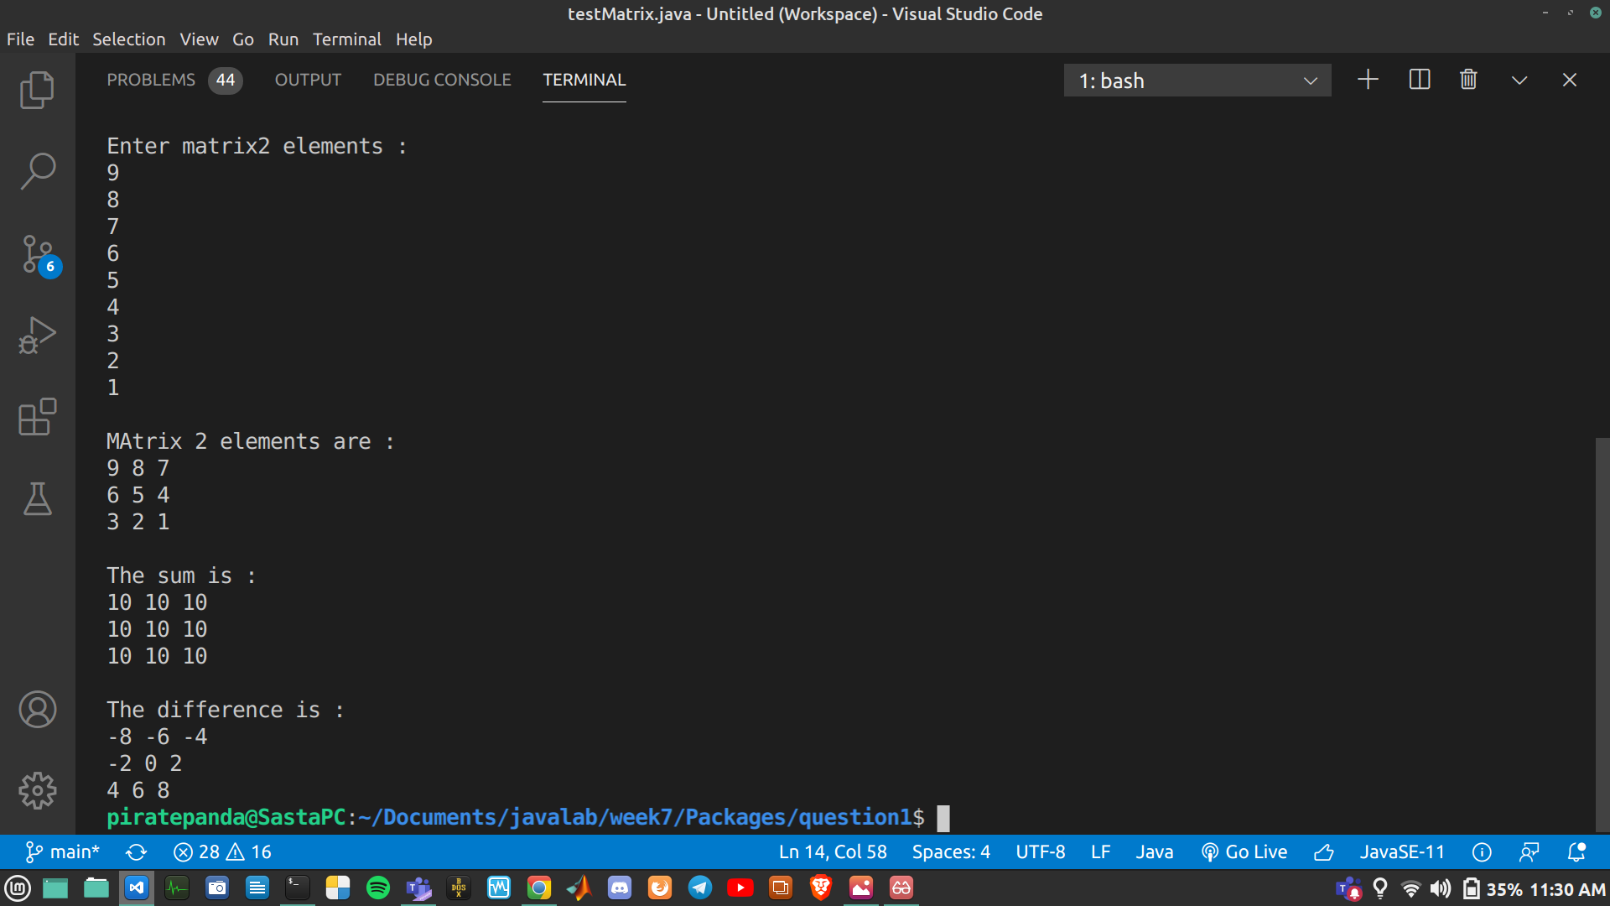
.

Q2.

person.java

package pack1;

public class person {
public String name;
public String sex;
public int age;

public person(String n, String s, int a){
name = n;
sex = s;
age = a;
}
}

staff.java

package pack2;

import pack1.person;

public class staff extends person {
public String dateOfJoin;
public int salary;
public staff(String name,String sex,int age,String doj,int sal){
super(name,sex,age);
dateOfJoin = doj;
salary = sal;
}
}

patient.java

package pack3;

import pack1.person;

public class patient extends person{
String condition;
int bill;
public patient(String name,String sex,int age,String cond,int b){
super(name,sex,age);
condition = cond;
bill = b;
}
public void display(){
System.out.println("Name = "+name);
System.out.println("Gender = "+sex);
System.out.println("Age = "+age);
System.out.println("Condition = "+condition);
System.out.println("Bill = "+bill);
}
}

doctor.java

package pack4;

import pack2.staff;

public class doctor extends staff{
String qualification;
String specialisation;
public doctor(String name,String sex,int age,String dateOfJoin,int salary,String qual,String spec){
super(name,sex,age,dateOfJoin,salary);
qualification = qual;
specialisation = spec;
}
public void display(){
System.out.println("Name = "+name);
System.out.println("Gender = "+sex);
System.out.println("Age = "+age);
System.out.println("Date of joining = "+dateOfJoin);
System.out.println("Salary = "+salary);
System.out.println("Qualification = "+qualification);
System.out.println("Specialisation = "+specialisation);
}
}

nurse.java

package pack5;

import pack2.staff;

public class nurse extends staff{
String type;
int shift;
public nurse(String name,String sex,int age,String dateOfJoin,int salary,String t,int sh){
super(name,sex,age,dateOfJoin,salary);
type = t;
shift = sh;
}
public void display(){
System.out.println("Name = "+name);
System.out.println("Gender = "+sex);
System.out.println("Age = "+age);
System.out.println("Date of joining = "+dateOfJoin);
System.out.println("Salary = "+salary);
System.out.println("Nurse Type = "+type);
System.out.println("Hours per day = "+shift);
}
}

HospitalDatabase.java

package mainPack;

import pack4.doctor;
import pack5.nurse;
import pack3.patient;

public class HospitalDatabase{
public static void main(String[] args) {
System.out.println("\nPatient : ");
patient patient1 = new patient("Arun","Male",24,"Cancer",20000);
patient1.display();
System.out.println("\nDoctor : ");
doctor doctor1 = new doctor("Vijay","Male",45,"02-02-00",50000,"MD","Gastro Intenstinal");
doctor1.display();
System.out.println("\nNurse : ");
nurse nurse1 = new nurse("Meera","Female",30,"03-03-02",35000,"Wet Nurse",8);
nurse1.display();
}
}

Output :

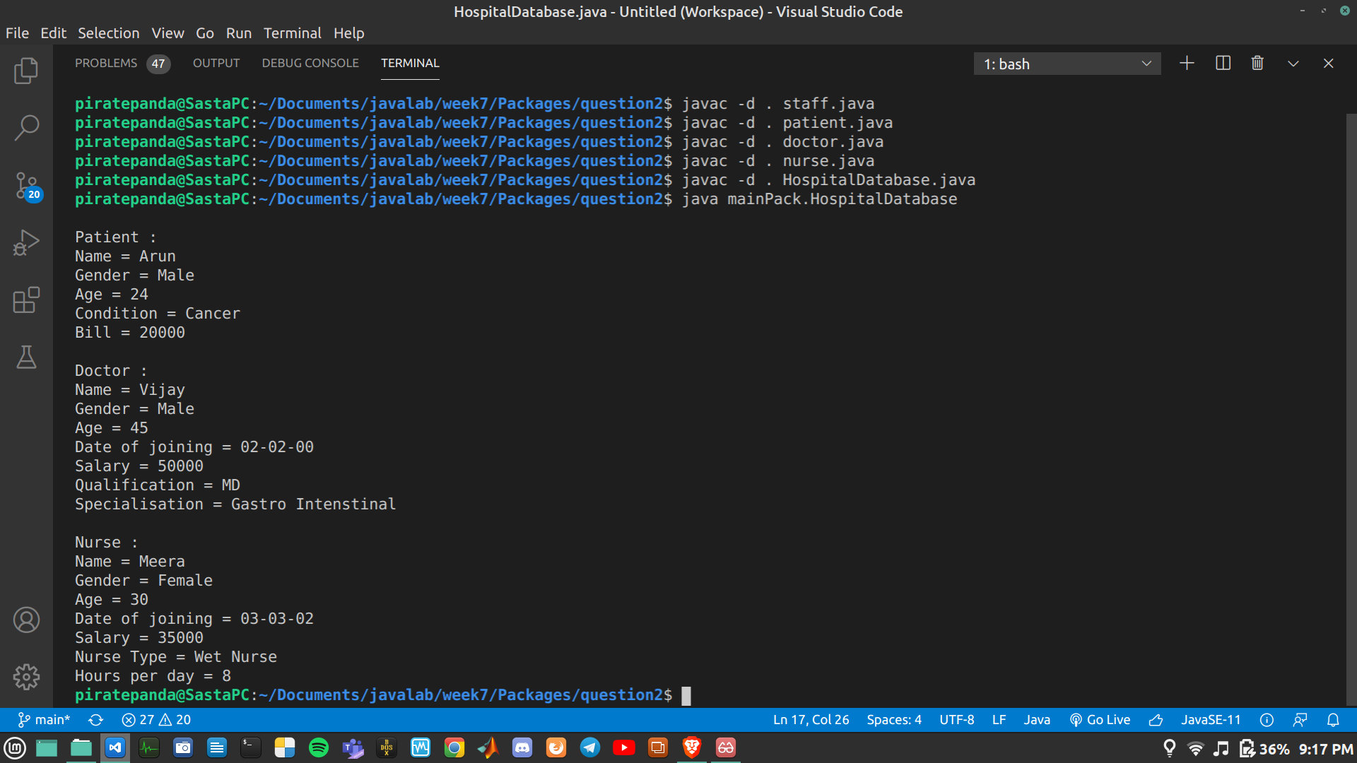
.

Interfaces

Q1.

